
BRAINWARE UNIVERSITY
398, Ramkrishnapur Road, Barasat, North 24 Parganas, Kolkata – 700 125

PERSONALIZED LEARNING RECOMMENDATION SYSTEM

A PROJECT REPORT
Submitted by
Roll Number | Registration number | Student Code | Student Name
24103460079 | 24103002860 of 2024-2025 | BWU/BCA/24/081 | Avinash Kr Mandal

In partial fulfillment for the award of the degree of
BACHELOR OF COMPUTER APPLICATION
in
DEPARTMENT OF COMPUTATIONAL SCIENCES

BRAINWARE UNIVERSITY
398, Ramkrishnapur Road, Barasat, North 24 Parganas, Kolkata – 700 125

ACKNOWLEDGEMENT

I would like to express my sincere gratitude to the Management and Faculty of Brainware University for providing me with the opportunity, academic resources, and supportive environment to complete this project titled “Personalized Learning Recommendation System.”
I would like to extend my heartfelt thanks to my project supervisor, Dr. Rahul Kumar Ghosh, Assistant Professor, for his valuable guidance, continuous support, constructive suggestions, and encouragement throughout the development of this project.
I am also thankful to Dr. Jayanta Aich, Head of the Department of Computational Sciences, and all the faculty members for their academic support and encouragement.
Finally, I would like to thank my family and friends for their constant motivation and support, which helped me complete this project successfully.
SIGNATURE: ___________________________
Avinash Kr Mandal
(BWU/BCA/24/081)

ABSTRACT

The Personalized Learning Recommendation System is a web-based educational recommendation prototype developed to suggest relevant learning resources based on students' academic information and course-related learning activity. The main objective of this project is to help students identify suitable study materials according to their enrolled courses and available learning-profile information.
The project uses an LMS Student Dataset containing 200 records, representing 164 unique students across five course modules. The dataset includes information such as course details, assessment types, previous attempts, average course feedback, learning activity and engagement-related attributes. Python and Pandas are used for data preprocessing, aggregation, analysis and preparation of student profiles.
A rule-based recommendation engine is implemented to prioritize learning resources using course-level information and predefined recommendation conditions. A curated catalogue of 17 learning resources is used, including notes, videos and practice materials with beginner and intermediate difficulty levels. The system generates three diversified recommendations for each student, resulting in 492 recommendations across 164 student profiles.
The application is developed using React.js for the frontend and FastAPI for the backend. The backend provides REST API endpoints to retrieve student profiles, dashboard statistics and personalized recommendations. CSV files are used to store the processed student profiles, recommendation results and resource catalogue.
The current prototype demonstrates an integrated approach to educational data processing and personalized resource recommendation through a web-based dashboard. It provides 100% operational recommendation coverage for the 164 student profiles in the processed dataset. However, this coverage does not represent recommendation accuracy or proven learning improvement. Further validation using real student feedback and learning outcomes is required to evaluate the effectiveness of the recommendations.

INDEX

- ACKNOWLEDGEMENT
- ABSTRACT
- LIST OF FIGURES
- LIST OF TABLES

- INTRODUCTION
- LITERATURE SURVEY
- SYSTEM ANALYSIS AND DESIGN
- IMPLEMENTATION
- OUTPUT SCREENSHOTS
- SOURCE CODE
- TESTING AND DEBUGGING
- CONCLUSION AND FUTURE ENHANCEMENT
- REFERENCES

LIST OF FIGURES

- Figure 3.1: System Architecture
- Figure 3.2: Recommendation Workflow
- Figure 4.1: Project Dashboard
- Figure 4.2: Student Profile Dashboard
- Figure 4.3: Personalized Learning Recommendations
- Figure 4.4: API Documentation (Swagger UI)

LIST OF TABLES

- Table 3.1: Technologies Used
- Table 3.2: Dataset Description
- Table 3.3: Student Profile Attributes
- Table 3.4: Recommendation Rules
- Table 7.1: Test Cases

INTRODUCTION

The Personalized Learning Recommendation System is a web-based application that recommends suitable learning resources based on student course information and learning activity.
It uses an LMS dataset, Python-based data processing and a rule-based recommendation engine to generate personalized learning suggestions.
The application uses React.js for the frontend and FastAPI for the backend.
1.1 Aim and Objectives
Aim: To develop a web-based system that provides personalized learning resource recommendations to students.
Objectives:
- Analyse student learning data.
- Preprocess and generate student profiles.
- Develop a rule-based recommendation engine.
- Create a learning resource catalogue.
- Build an interactive dashboard using React.js.
- Develop REST APIs using FastAPI.
- Display personalized recommendations.
- Test the complete application.

1.2 Scope and Limitations

Scope:
- Analyses student course and learning activity data.
- Generates student learning profiles.
- Recommends notes, videos and practice resources.
- Provides a web-based dashboard.
- Displays student statistics and recommendations.

Limitations:
- Uses a limited dataset of 200 records.
- Recommendation logic is rule-based, not a trained ML model.
- Some engagement values are missing in the dataset.
- Recommendation effectiveness requires further validation.
- Resource catalogue is limited to 17 resources.

2. LITERATURE SURVEY

Personalized learning helps students access educational content according to their learning needs.
Learning Management Systems (LMS) collect information about student participation, assessments and learning activities.
Recommendation systems use this information to suggest relevant learning materials. Rule-based methods use predefined conditions to generate recommendations.
This project applies these concepts to recommend learning resources using student course information and learning activity.

2.1 Existing and Proposed System
Existing System:
- Students manually search for learning resources.
- General learning materials may not suit every student.
- Resource selection can be time-consuming.
Proposed System:
- Analyses available student learning data.
- Generates student profiles.
- Applies rule-based recommendation logic.
- Suggests relevant notes, videos and practice materials.
- Displays recommendations through a web dashboard.

3. SYSTEM ANALYSIS AND DESIGN
3.1 System Analysis
The system analyses student learning information to recommend suitable educational resources.
Key Requirements:
- Student profile management.
- Course-wise learning data analysis.
- Resource catalogue management.
- Personalized recommendations.
- Interactive dashboard.
- REST API integration.

3.2 System Modules
Module | Description
Data Processing | Cleans and processes LMS data.
Student Profiling | Generates student profiles.
Resource Catalogue | Stores 17 learning resources.
Recommendation Engine | Applies predefined rules.
Backend API | Provides data using FastAPI.
Frontend Dashboard | Displays profiles and recommendations.

3.3 Technologies Used
Technology | Purpose
Python
  Data processing and recommendation logic.
React.js | Frontend development.
Pandas
  Dataset analysis and manipulation.
Visual Studio Code | Development environment.
JavaScript | Frontend functionality.
HTML & CSS | Webpage structure and styling.
CSV
  Data storage.

3.4 Dataset Attributes
Attribute |  | Description
Student ID |  | Unique student identifier.
Code Module |  | Course module code.
Course Name |  | Name of the course.
Assessment Type |  | Quiz or Assignment.
Previous Attempts |  | Number of previous attempts.
Average Feedback |  | Average course feedback.
Total Clicks |  | Recorded learning activity clicks.
Days Viewed |  | Number of days viewed.
No. of Exercises |  | Recorded exercise activity.

3.5 System Architecture
The system follows a three-layer architecture:
- Frontend: React.js displays the dashboard and recommendations.
- Backend: FastAPI handles API requests and processes data.
- Data Layer: CSV files store student profiles, recommendations and resources.
The frontend communicates with the backend through REST APIs.

3.6 Recommendation Methodology
The system uses a rule-based recommendation approach.
- Student course information is retrieved.
- Previous attempts are analysed at course level.
- Practice resources receive higher priority when previous attempts exist.
- Beginner resources are prioritized for revision.
- Other resources are suggested as additional learning materials.
- The system displays the top three recommendations for each student.
Recommendation Priorities:
Condition | Priority
Previous attempts exist and resource is Practice | Priority 1
Resource difficulty is Beginner | Priority 2
Other resources | Priority 3

4. IMPLEMENTATION
The system was implemented using Python, FastAPI and React.js. The backend processes student data and generates learning recommendations, while the frontend displays the results through an interactive dashboard.

4.1 Data Processing and Student Profiling
- Loaded the LMS dataset using Pandas.
- Processed student course and learning activity information.
- Generated profiles for 164 unique students.
- Prepared course-wise information for recommendation generation.
- Handled missing engagement values without treating them as zero.

4.2 Recommendation Engine
The recommendation engine uses predefined rules to select suitable learning resources.
- Checks previous attempts for a student in a course.
- Prioritizes practice resources when previous attempts exist.
- Suggests beginner resources for revision.
- Adds other resources as additional learning material.
- Generates the top three recommendations for each student.
A total of 492 recommendations were generated for 164 student profiles.
4.3 Backend API Implementation
The backend was developed using FastAPI to provide data to the React.js frontend through REST APIs.
The following API endpoints were implemented:
- GET / – Checks the backend application.
- GET /api/health – Checks API health status.
- GET /api/stats – Returns project statistics.
- GET /api/students – Returns the student list.
- GET /api/students/{student_id} – Returns a selected student's profile.
- GET /api/students/{student_id}/recommendations – Returns personalized recommendations.
These APIs connect the frontend with the backend and display student information and recommendations on the dashboard.
4.4 Frontend Implementation
The frontend was developed using React.js to provide an interactive user interface.
The dashboard includes:
- Project overview and summary statistics.
- Student selection option.
- Student learning profile details.
- Personalized learning recommendations.
- Explanation of why each resource was recommended.
- Backend API connection status.
The frontend fetches student information and recommendations from the FastAPI backend and displays them in an organized format.

5. OUTPUT SCREENSHOTS
This chapter presents the screenshots of the developed Personalized Learning Recommendation System. The screenshots demonstrate the dashboard, student profiles, personalized recommendations and backend API documentation.
5.1 Project Dashboard: Main dashboard with summary statistics.
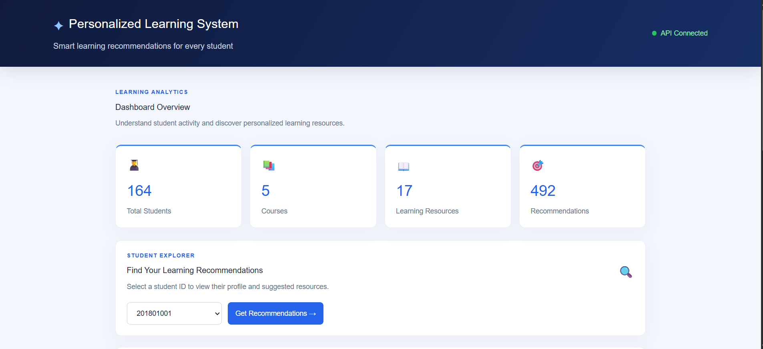
Figure 5.1 – Project Dashboard: Main dashboard with summary statistics.
5.2 Student Profile 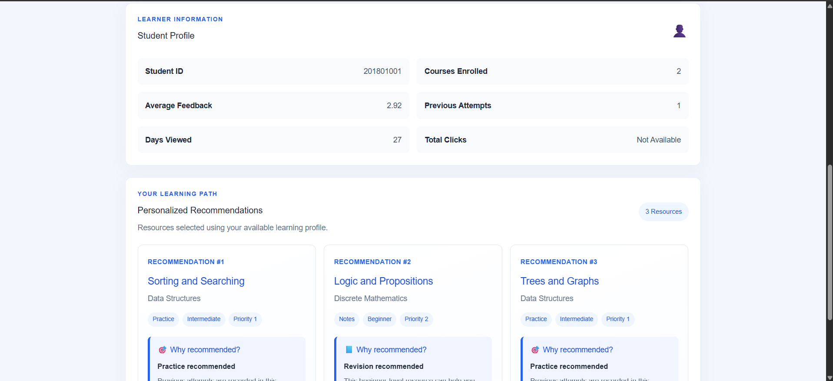

Figure 5.2: Student Profile: Selected student's learning profile.

5.3 Personalized Recommendations
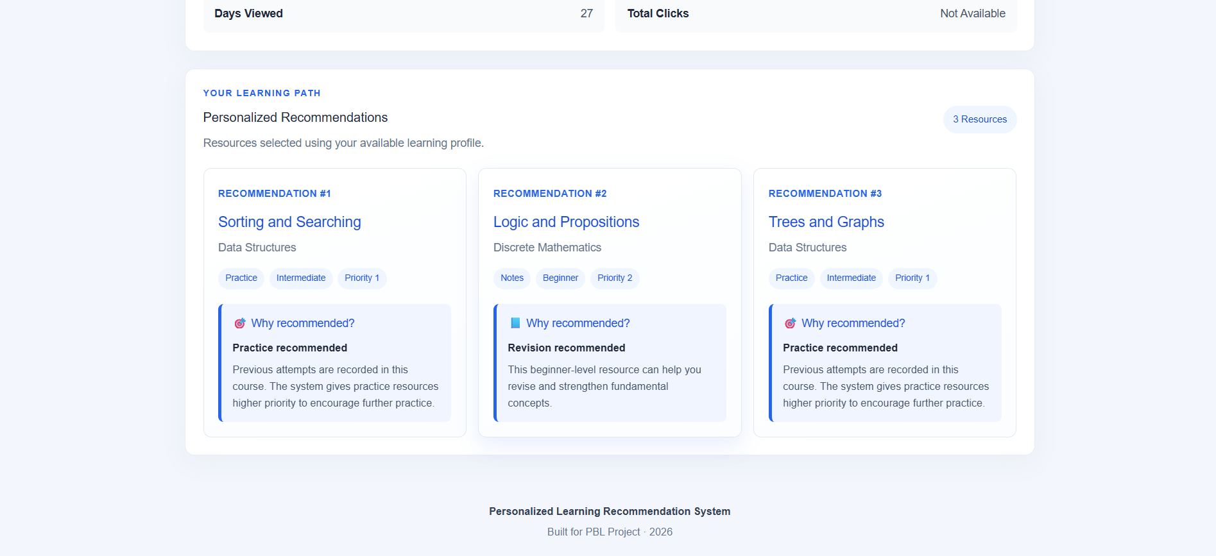
Figure 5.3: Learning Recommendations: Top 3 recommendations with reasons.

5.4 Backend API Documentation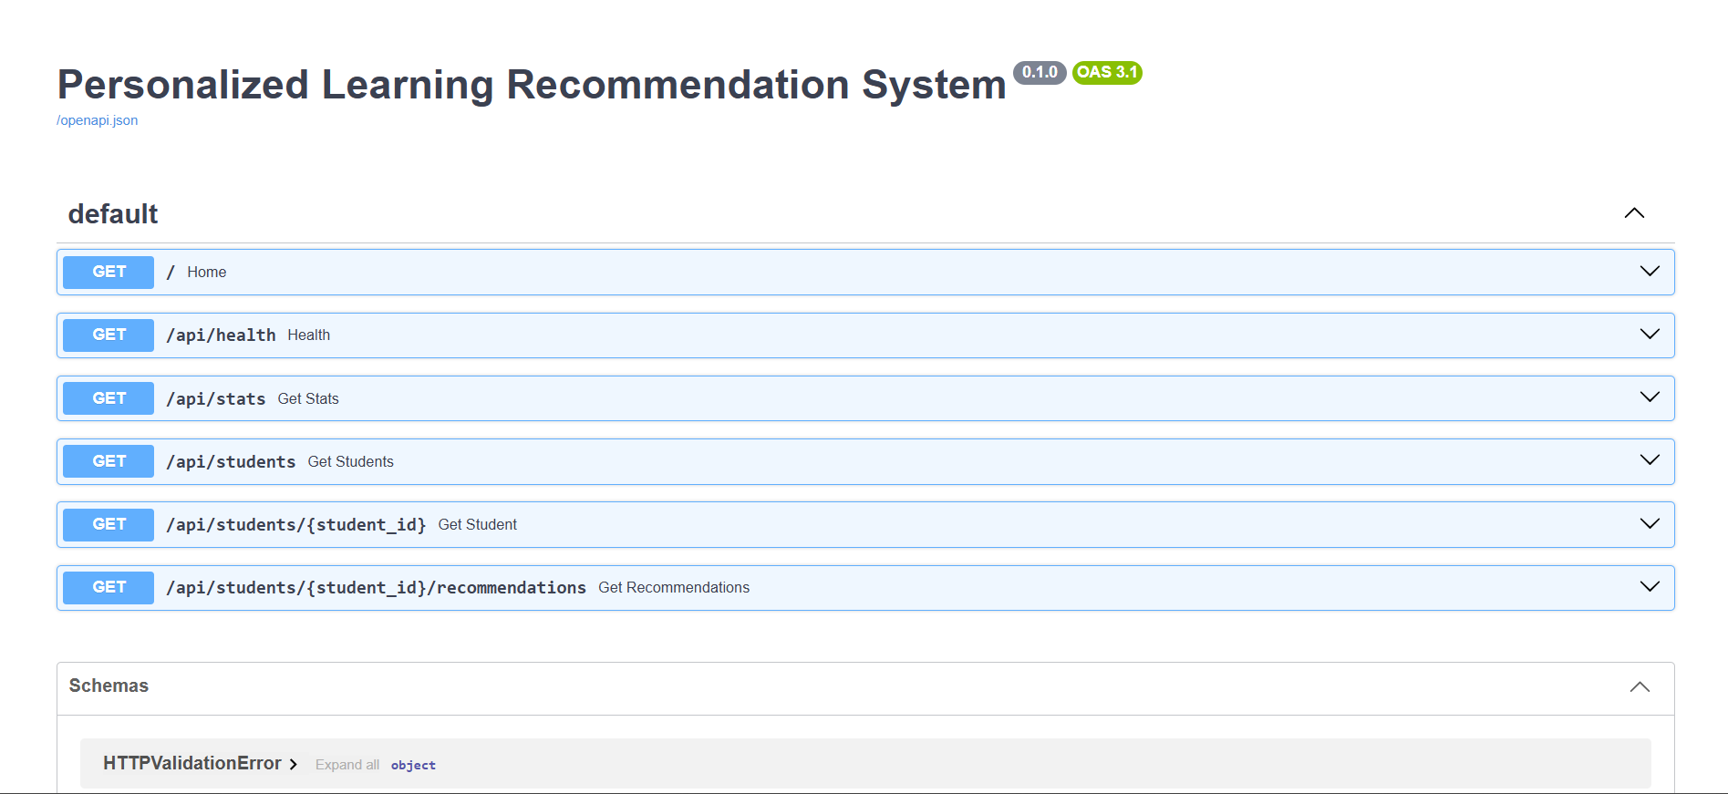

Figure 5.4: API Documentation: FastAPI Swagger UI showing available endpoints.

6. SOURCE CODE
This chapter presents the important source code components of the Personalized Learning Recommendation System.
The project source code is organized into two main parts:
- Backend: Developed using Python and FastAPI. It handles dataset processing, student profiles, recommendation generation and REST API endpoints.
- Frontend: Developed using React.js. It displays the dashboard, student information and personalized learning recommendations.
Important code snippets from the backend and frontend are presented in this chapter to explain the implementation.
6.1 Data Processing – Python
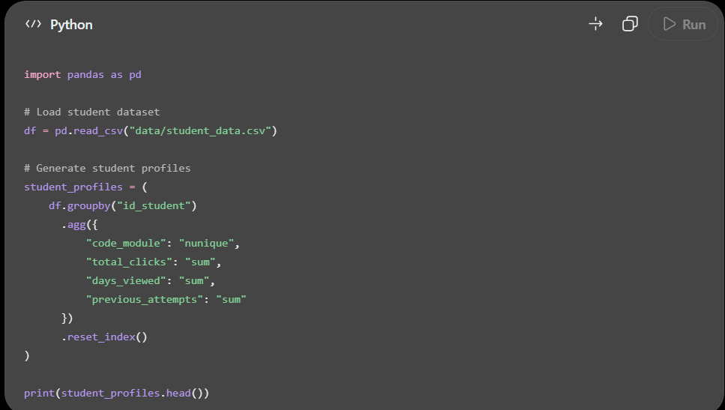
Figure 6.1 – Student Data Processing
6.2 Recommendation Engine – Python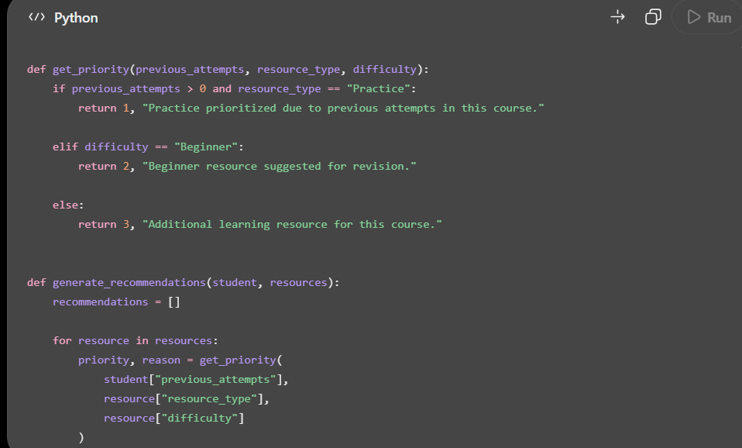
Figure 6.2 – Rule-Based Recommendation Engine
6.3 Backend API – FastAPI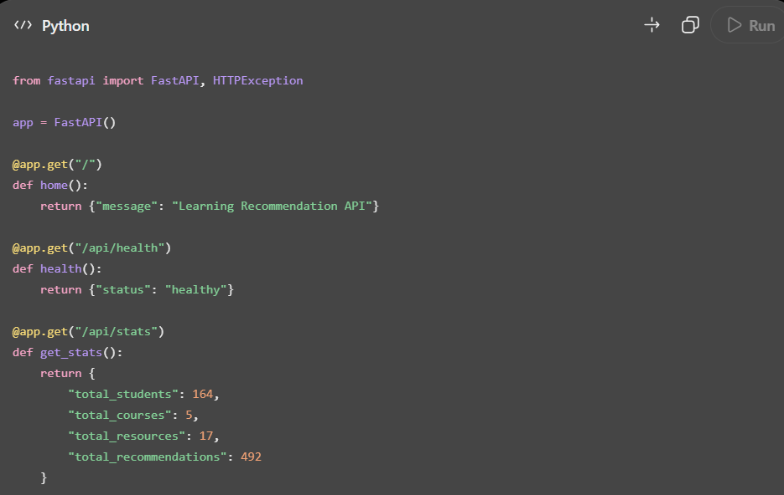 Figure 6.3 – FastAPI Backend Endpoints

6.4 Frontend API Integration – React.js

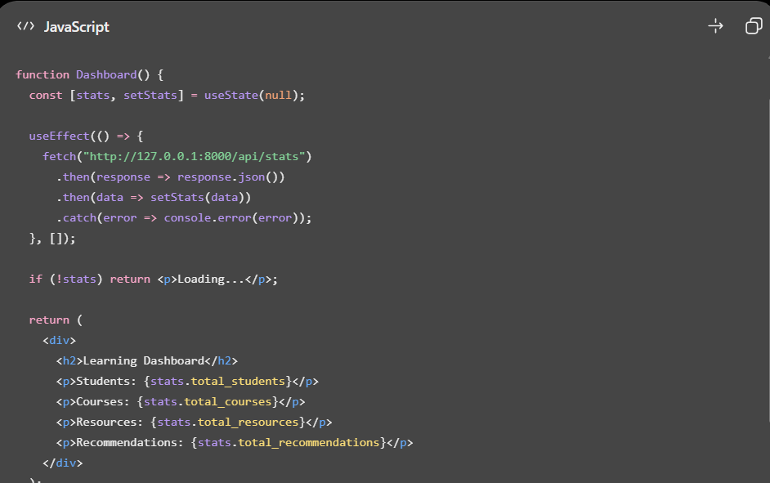
Figure 6.4 – React Dashboard API Integration

7. TESTING AND DEBUGGING
Testing was performed to verify the functionality and reliability of the Personalized Learning Recommendation System.
The main testing objectives were:
- Verify backend API connectivity.
- Check student profile retrieval.
- Verify recommendation generation.
- Validate dashboard statistics.
- Test frontend and backend integration.
- Identify and fix errors during development.
7.2 Test Cases
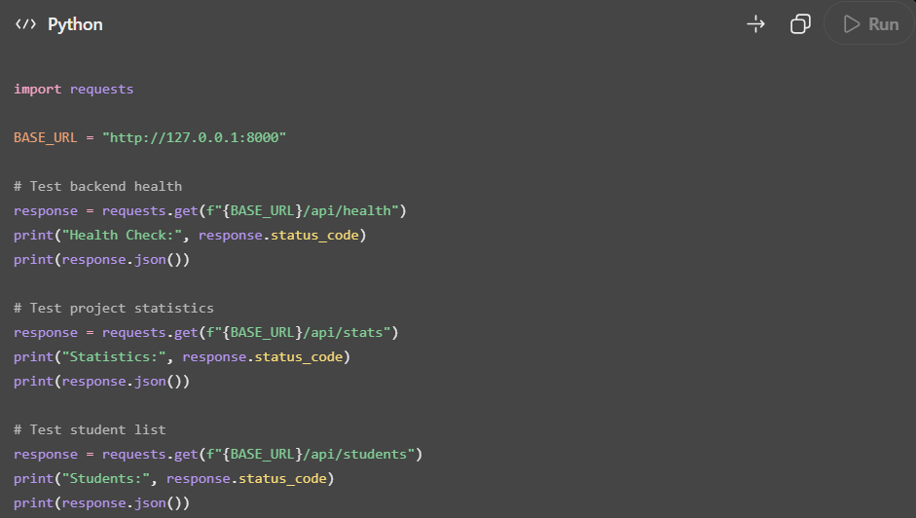
Figure 7.1 – Backend API Testing

7.3 Recommendation Testing – Python
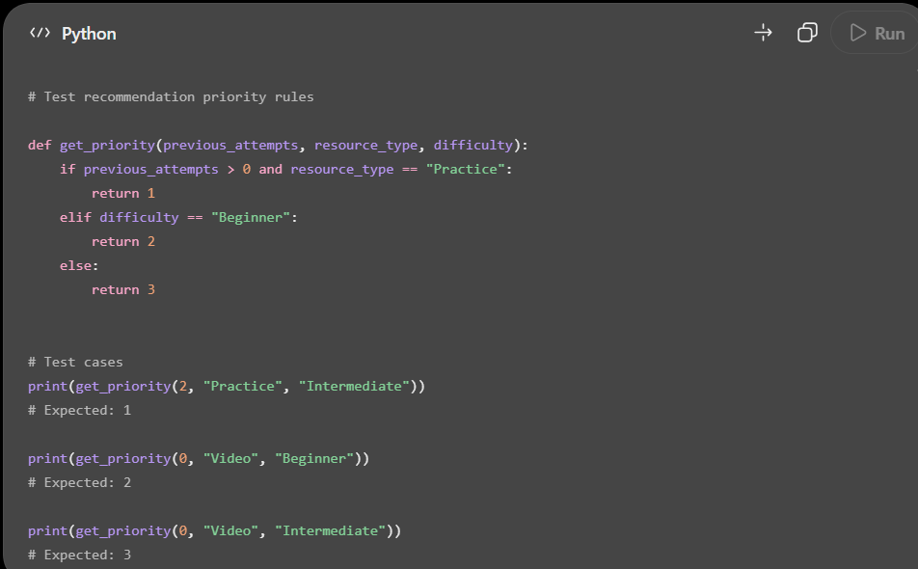

Figure 7.2 – Recommendation Rule Testing

7.4 Test Cases
Test Case | Expected Result
Backend health check | API returns healthy status
Statistics API | Project statistics are returned
Student list API | Student records are returned
Student profile API | Selected profile is returned
Recommendation API | Top 3 recommendations are returned
Frontend integration | Dashboard displays backend data

7.5 Debugging
During development, some errors were identified and fixed.
- Missing Path import – Fixed by importing Path from pathlib.
- Missing Pandas import – Fixed by importing pandas.
- Undefined HTTPException – Fixed by importing it from FastAPI.
- API connectivity issues – Checked backend and frontend configuration.
- Data handling issues – Verified CSV file paths and dataset processing.
After debugging, the backend API endpoints were tested and returned successful HTTP responses.

8. CONCLUSION AND FUTURE ENHANCEMENT

8.1 Conclusion
The Personalized Learning Recommendation System was developed to provide students with suitable learning resources based on their course information and learning activity.
The system processes an LMS dataset containing 200 records and 164 unique students across 5 course modules. It uses a rule-based recommendation engine and a catalogue of 17 learning resources.
The application generates 492 recommendations for 164 student profiles and displays the results through a React.js dashboard connected to a FastAPI backend.
The project demonstrates how student data and predefined rules can support personalized learning resource suggestions. However, recommendation effectiveness and learning improvement require further evaluation using actual student feedback and outcomes.

8.2 Future Enhancements
The system can be improved in the following ways:
- Use larger and more diverse student datasets.
- Implement machine learning-based recommendation models.
- Add more learning resources and course categories.
- Include student feedback to improve recommendations.
- Integrate a database for better data management.
- Add student login and profile management.
- Evaluate recommendation quality using suitable performance metrics.
- Deploy the application online for wider accessibility.

REFERENCES

- Open University Learning Analytics Dataset (OULAD), Open University.
- Python Documentation – https://docs.python.org/3/
- Pandas Documentation – https://pandas.pydata.org/docs/
- FastAPI Documentation – https://fastapi.tiangolo.com/
- React Documentation – https://react.dev/
- Vite Documentation – https://vite.dev/

